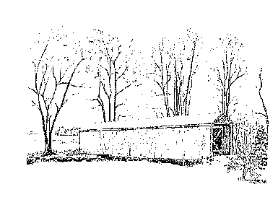
VILLAGE OF LYNCHBURG
155 S. Main St. ~ P.O. Box 402
Lynchburg, OH 45142
Phone: 937-364-2241
dmount@lynchburgohio.org

ADD A NAME TO MY ACCOUNT

I _______________________________________ would like to add to my account,
Print name of account holder

_________________________________________, and a copy of their ID is required.
Print name of person that I am adding

Account Number: ____________________

Effective date: _______________________

Address on the account: ___________________________________________________

__________________________________ _________________
Signature of account holder Date

__________________________________ __________________
Signature of person I am adding Date

