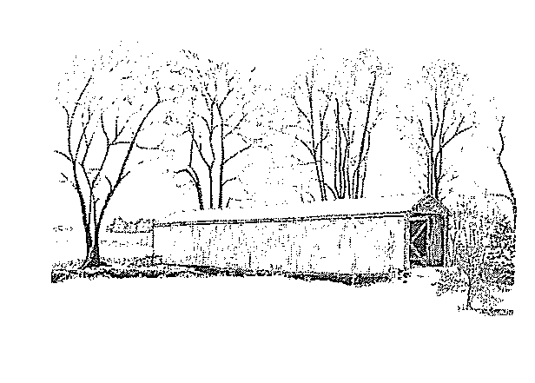
VILLAGE OF LYNCHBURG
155 S. Main St. ~ P.O. Box 402
Lynchburg, OH 45142
Phone: 937-364-2241 - Fax: 937-364-2241
www.lynchburgohio.org

SERVICE TRANSFER FORM

I GIVE MY PERMISSION AS THE DEPOSIT HOLDER TO TRANSFER MY SERVICE TO

THE ADDRESS OF ______________________________ ON THE DATE OF _________________.

A FINAL READING WILL BE OBTAINED AND THE WATER WILL BE TURNED OFF AT THE

ADDRESS OF ___________________________________ ON THE DATE OF _________________.

____________________________ ____________________________
Print Name Signature

____________________________ ____________________________
Phone Number Date

