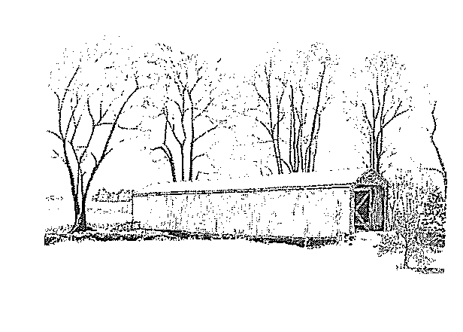
VILLAGE OF LYNCHBURG
155 S. Main St. ~ P.O. Box 402
Lynchburg, OH 45142
Phone: 937-364-2241 - Fax: 937-364-2241
www.lynchburgohio.org

TEMPORARILY AWAY FORM

I GIVE MY PERMISSION AS THE DEPOSIT HOLDER TO HAVE THE VILLAGE OF LYNCHBURG SHUT THE WATER OFF AT ______________________________ ON __________________ (AT WHICH TIME A $25 DISCONNECT FEE WILL BE CHARGED).
THE WATER WILL NEED TO BE TURNED BACK ON ____________________ (AT WHICH TIME A $25 RECONNECT FEE WILL BE CHARGED).
THIS IS A TEMPORARY SHUT OFF WHILE I’M AWAY. THIS RELIEVES THE VILLAGE OF LYNCHBURG OF ANY LIABILITY.
Send the bill to my temporary address of:
________________________________________________________________________
Street Address City State Zip Code

____________________________ ____________________________
Print Name Signature

____________________________ ____________________________
Phone Number Date

